Question 6 https://github.com/PATIENCE-256/my-exam-work

6 a)

Access modifiers in OOP are used to control the visibility and accessibility of classes, methods, and variables.
They help to:
- Protect data (Encapsulation)
- Prevent unauthorized access
- Improve security
- Control how classes interact with each other
They define where a class member can be accessed from.

6 b)

Access Modifier | Private | Default | Protected | Public
Defining class  Class in the same package  Subclass in a different package  Non-subclass in a different package | Yes | Yes | Yes | Yes
 | No | Yes | Yes | Yes
 | No | No | Yes | Yes
 | Yes | Yes | Yes | Yes

6 c)

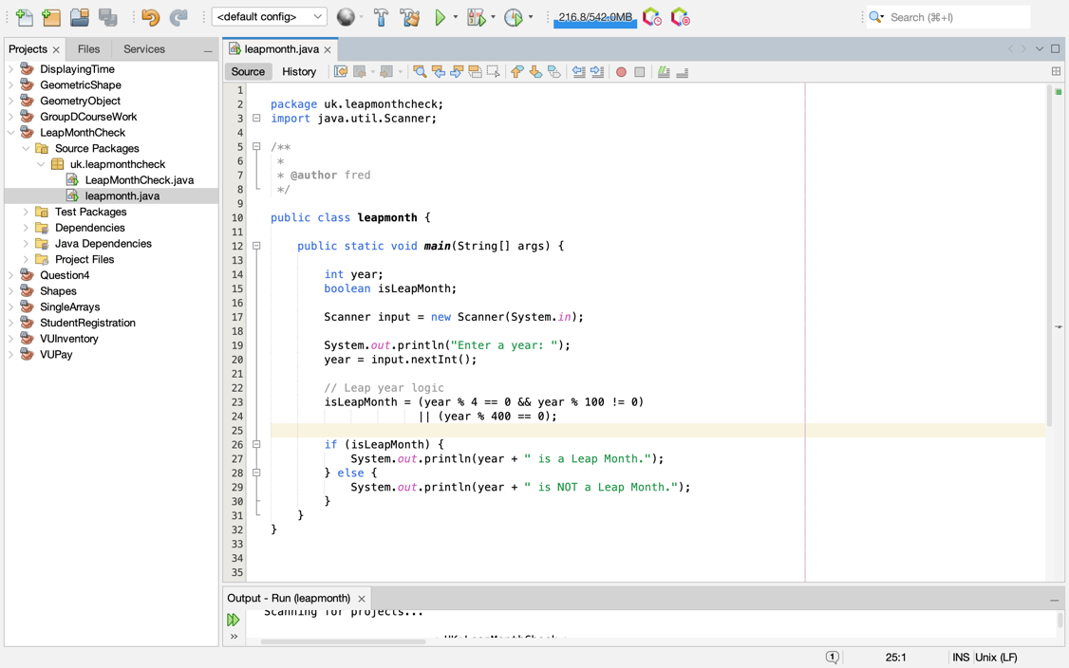
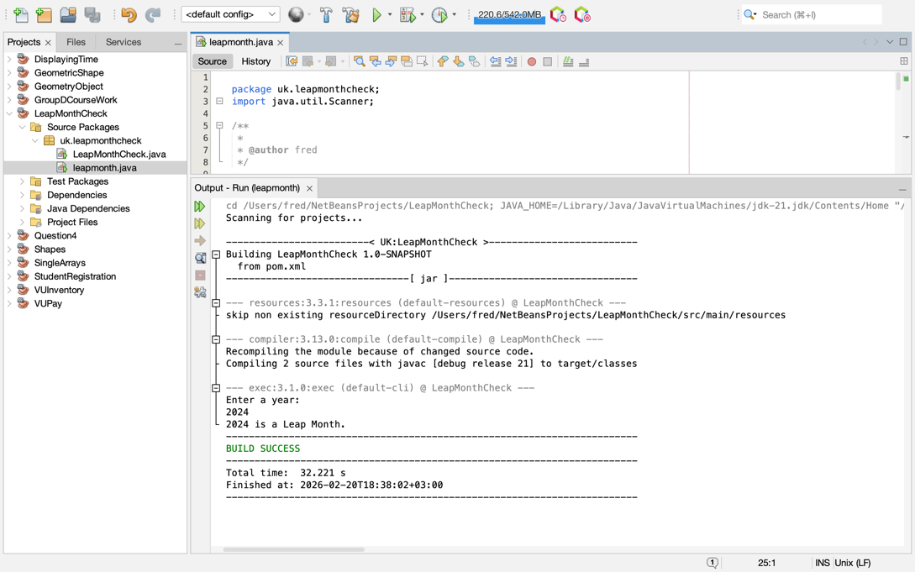
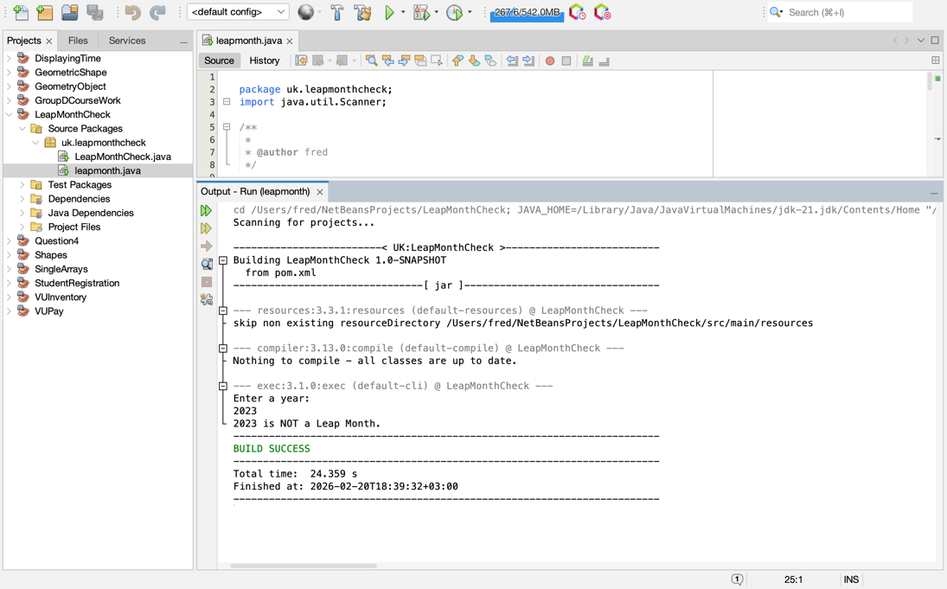

https://github.com/PATIENCE-256/my-exam-work

